**LAB Report #2: Control of Pneumatic Artificial Muscles using Pulse Width Modulation(PWM)**

Reporter: MINGSHAN HE (2022-24052, hemingshan@snu.ac.kr)

Instructor: Yong-Lae Park

Lab Assistant: Tae Hwa Hong, Sung Jin Kim

**Results**

1. Provide a graph of **Force vs. Time** with duty cycles of **25%, 50%, 75%, and 100%** for each muscle. Prepare four plots for selected muscles in different diameters.

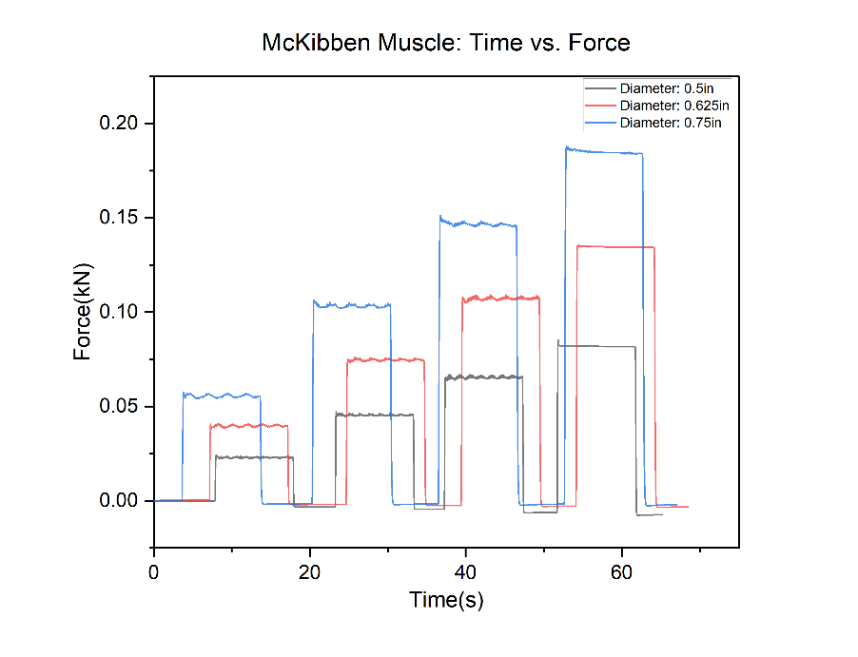

This Graph has shown three types of McKibben Muscles which is generated with four different air pressures. The black, red, blue line respectively represent the diameter of 0.5in, 0.625in and 0.75in. And there are four peaks which are represents four different ai pressures.

1. Provide the frequency of the PWM you used.

In this lab, we use the 980Hz frequency of the PWM.

1. Define the rise/fall time and the overshoot percentage of each experiment for each duty cycle and provide the values

|  |  |  |  |  |
| --- | --- | --- | --- | --- |
| Diameter (in) | Duty Cycle (%) | Rise Time(s) | Fall Time(s) | Overshoot |
| 0.5 | 25 | 0.14 | 0.18 |  |
| 0.5 | 50 | 0.14 | 0.22 |  |
| 0.5 | 75 | 0.18 | 0.16 |  |
| 0.5 | 100 | 0.12 | 0.18 |  |

|  |  |  |  |  |
| --- | --- | --- | --- | --- |
| Diameter (in) | Duty Cycle (%) | Rise Time(s) | Fall Time(s) | Overshoot (%) |
| 0.625 | 25 | 0.16 | 0.18 |  |
| 0.625 | 50 | 0.20 | 0.18 |  |
| 0.625 | 75 | 0.16 | 0.22 |  |
| 0.625 | 100 | 0.14 | 0.16 |  |

|  |  |  |  |  |
| --- | --- | --- | --- | --- |
| Diameter (in) | Duty Cycle (%) | Rise Time(s) | Fall Time(s) | Overshoot (%) |
| 0.7 | 25 | 0.22 | 0.20 |  |
| 0.7 | 50 | 0.22 | 0.22 |  |
| 0.7 | 75 | 0.24 | 0.30 |  |
| 0.7 | 100 | 0.22 | 0.34 |  |

1. Provide photos and description of our experimental setup.

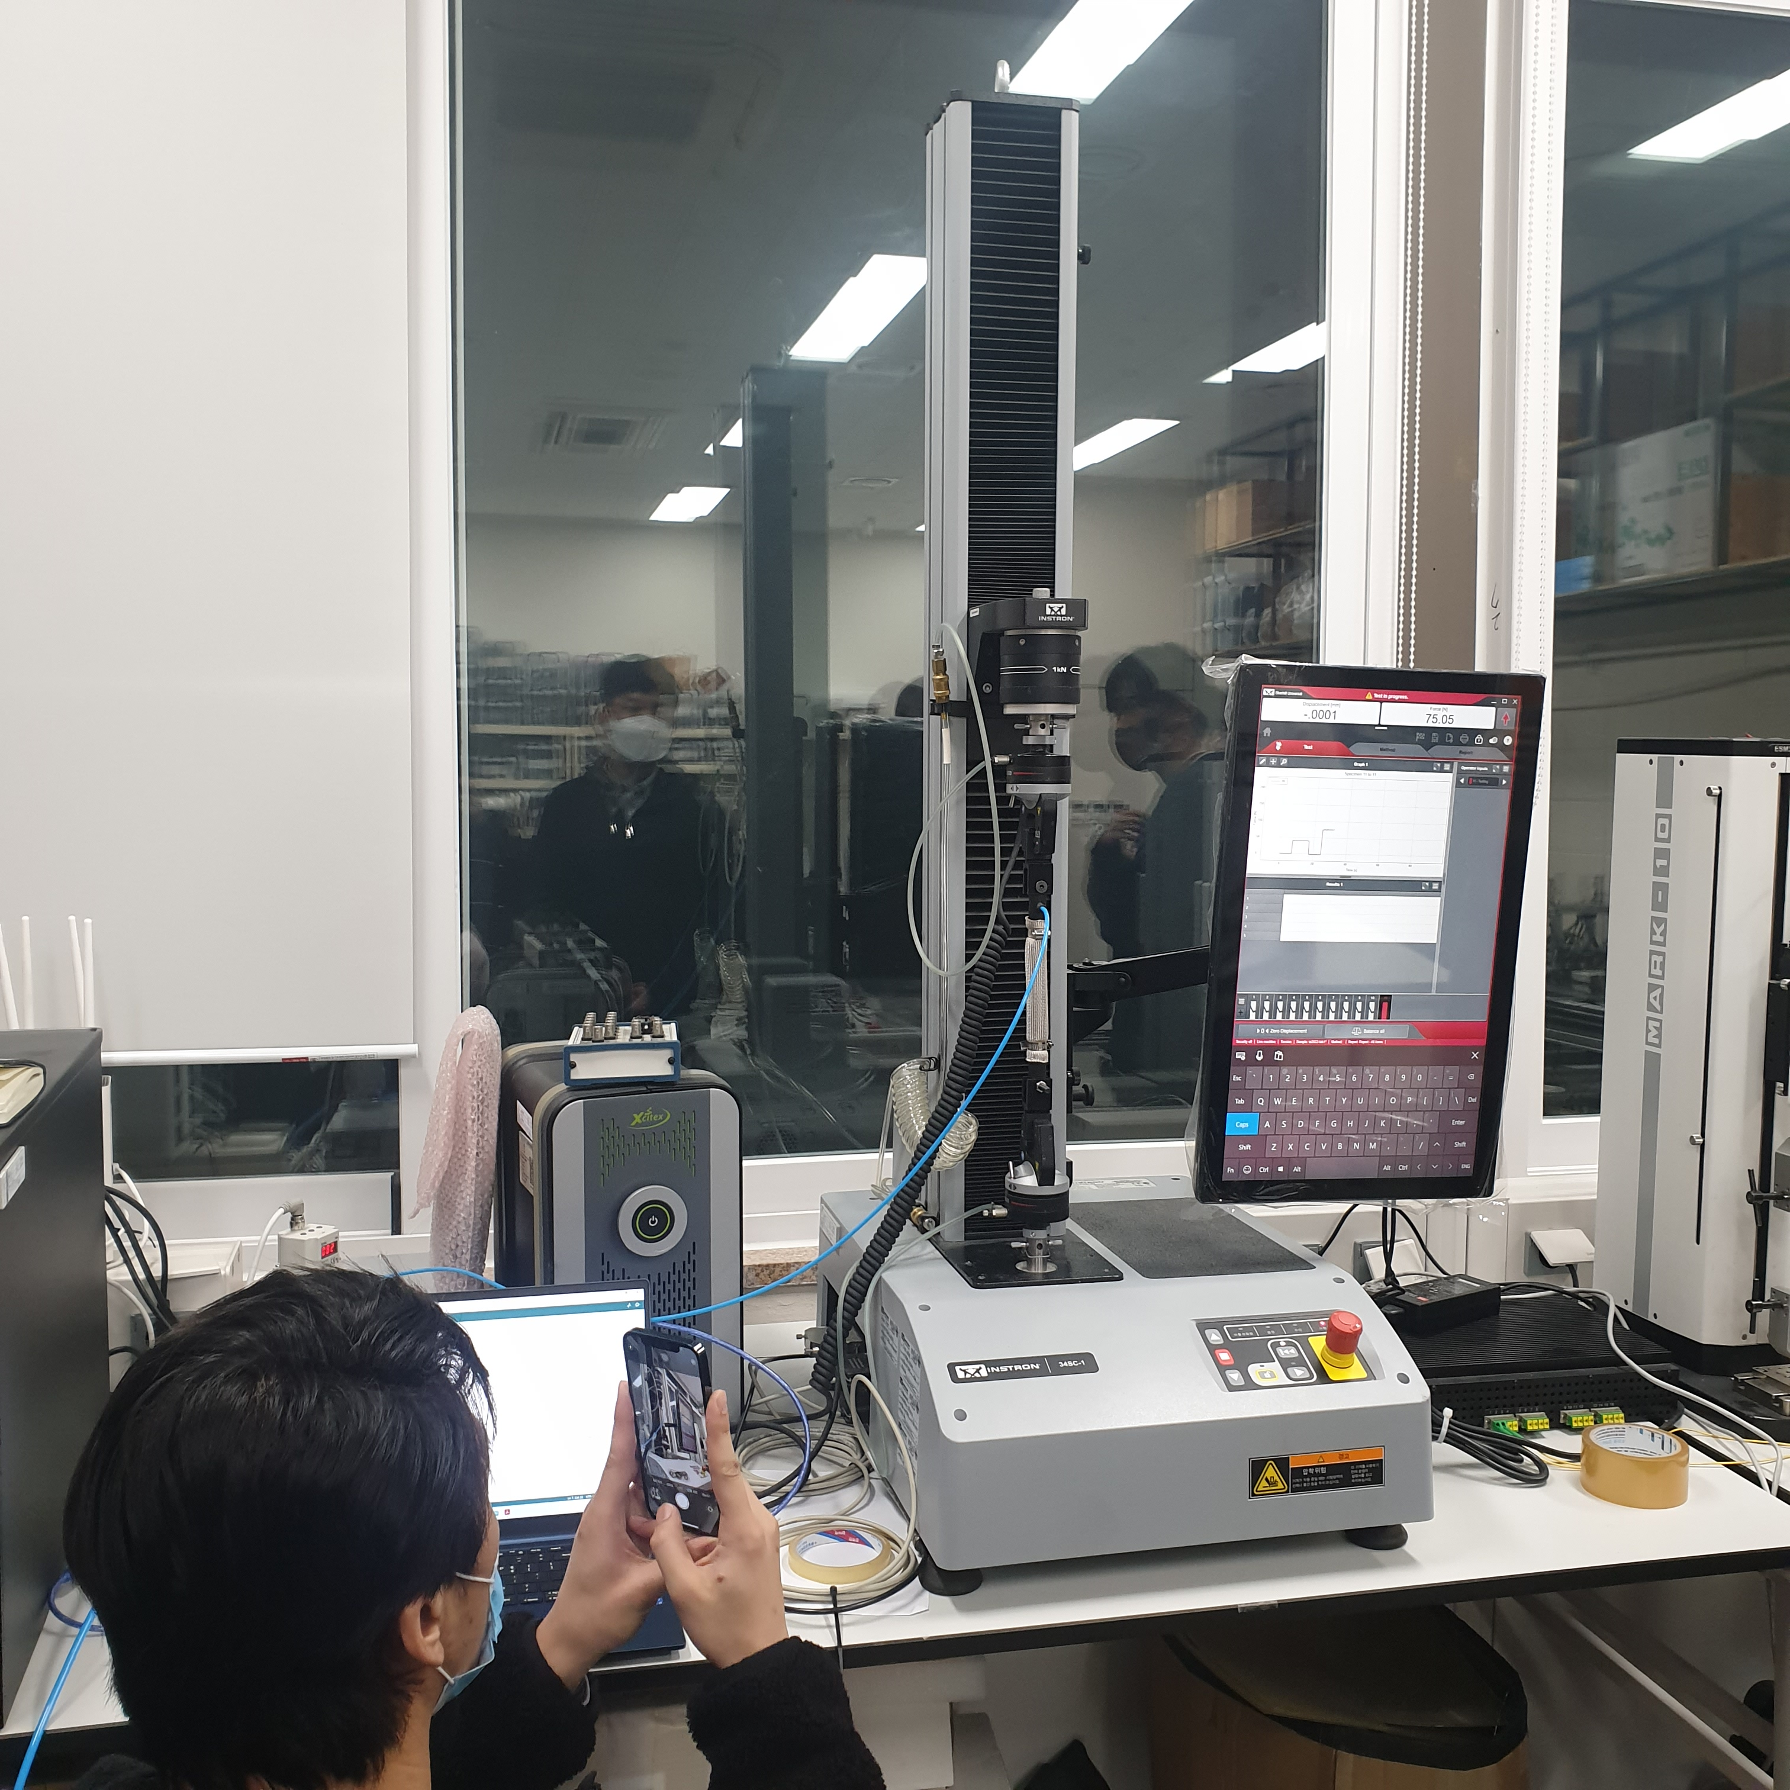

In this setup, we use the Arduino Uno with the micro control board to provide PWM signal with in PIN#6 and the Regulator Valve (ITV-2030-212cl from SMC) is used to generate proper air pressure with the input of PWM signal. And we have three McKibben Muscles with different diameter setting. In this lab, we test these artificial muscles in different PWM signals exactly the duty cycle.

**Discussion**

1. Why is the use of PWM important when controlling the valves?

It could control the valves in analog signals and using the PWM could control it continuously. And the important advantage of PWM control is fewer consumption of compressed air. It is possible to control continuously the flow rate by changing the duty cycle. So it is important to generate continuous signal to generate various air pressure.

1. What are the advantages and limitations of PWM?

There are several advantages of PWM. It is cheap to make and the signal can be generated very easily at demodulation and noise can be also separated easily. The low power consumption also could make it be efficiency up to 90%. And it can utilize very high frequency which is determined by the MCU or devices. But it also have some limitations. The system requires a semiconductor device with low turn ON and turn OFF times, which also makes the circuit complexity .

1. Describe alternatives to PWM to control actuators in general. What other alternatives can be used for this particular actuator?

I think it could use the alternative register which could generate different current and voltage continuously but it is hard to control preciously. I also think PID control is proper to control the actuator. If the air pressure sensor could be provided, the feedback error control exactly PID is the great choice to control it.

1. How did you determine your PWM frequency? What is the highest frequency you can use for the valve provided?

Arduino Uno is used in this lab, and the pin#6 is used with the PWM output pin number. In this board, the pin#5 and pin#6 provide the 980 Hz. The highest response time is 0.1sec which is provided by the device datasheet.